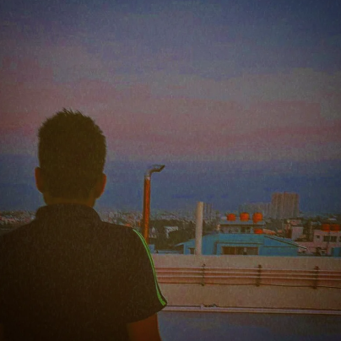

dry throat,
dark lips,
tongue,
perched against,
a palate not smooth,
metallic taste,
in an empty mouth,
a racing heart,
your ribcage,
that'll burn through,

heavy eyes, a confused gaze,
broken lashes, and a bloated face,
hair, looking worse,
than when Medusa's enraged,
a dizzy mind, not knowing,
if it is dreaming, or is it really awake,

The bowels churn, the feet press against, each other,
the friction, easing,
the discomfort crawling under,

your skin, paper thin,
eroded from all,
the toxins within,

you're holding on,
you're holding on,
you're holding on,
to the breaths,
you're taking in.

